Where is the Relief?

The Disconnect Between US Aid and the Syrian Refugee Population

Marissa Marinello

The University of Texas at Austin

Spring – 2019

**Research Background**

The Syrian Civil War began in March of 2011. Now in its eighth year, the war created the world’s largest humanitarian crisis of refugees since World War II. As of today, the Syrian refugee population totals 5,648,002 individuals. The population count fluctuates slightly from month to month but remains shockingly high. Of those individuals, 64% (3,621,330) are located in Turkey, 16.7% (944,613) are located in Lebanon, 11.7% (660,393) are in Jordan, and the remaining 7.4% (421,666) are in Iraq, Egypt and North Africa.[1] The United Nations High Commissioner for Refugees (UNHCR) reported in January 2019, there were 6.2 million Syrians internally displaced, and 11.7 million in need of humanitarian relief.[2]

To respond to this humanitarian crisis, the UNHCR began the Regional Refugee and Resilience Plan (3RP) in 2015. This plan targets the five man countries in the region impacted by the Syrian Civil War: Turkey, Lebanon, Jordan, Iraq, and Egypt – not Syria specifically. In each country impacted by the Syrian refugee crisis, unique needs arise due to the vulnerability of the refugee population, the host populations’ social and economic state, and the refugee response policies of each country. Not only do host countries have to respond to the influx of Syrian refugees and the sudden population increase, but also for the nearly one million children born as refugees, and their own local populations. This puts an enormous strain on resources that were perhaps already in high demand by the host population. As a result, this comprehensive response plan, created by over 270 partnering organizations, set a budget for 2019 of $5.5 billion USD. The budget is divided into two categories of aid: 3.2 billion towards a “refugee component,” which is more emergency aid, and 2.3 billion towards a “resilience component,” which targets long term and sustainable development aid.[3] Since the beginning of 3RP, the yearly appeal made by the UNHCR and partners to the plan is consistently unmet, and the budget continues to grow. Figure 1, below, demonstrates this:

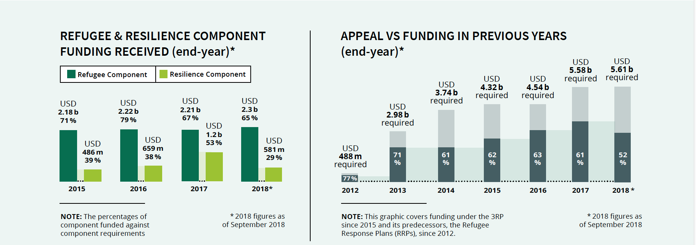

*Figure 1. 3RP Appeal vs. Funding. UNHCR 3RP Regional Strategic Overview[4].*

The United States is a crucial partner in the response to Syria. The United Nations donor profiles page shows that since at least 2012, the United States has been the top donor to all UNHCR programs.[5] Specifically relating to Syria, from 2012 through 2017, and again in 2019 the United States was the top donor to appeal funding of 3RP.[6] Despite the generosity of the United States and other governments involved in the 3RP response, needs are still unmet. More specifically, funding for the resiliency component for refugee situations is dramatically underfunded. This suggests that international funding focuses on emergency relief rather than long term relieve put towards development and sustainability.

The UNHCR identifies the resiliency component of the 3RP as addressing “the resilience, stabilization and development needs of impacted and vulnerable communities and aims to strengthen the capacities of national actors to lead the crisis response”.[7] This seeks to address the building blocks of a stable society and country, and to bolster the ability of host countries to take the lead in development rather than relying solely on outside forces. This approach will ultimately strengthen the self-reliance of communities and allow countries to determine their future. An approach that works at targeting long term development needs for refugees and host communities is crucial, albeit more difficult to fund. Long term investments in refugees and host communities become more critical as refugee situations become more protracted – meaning they are situations without a foreseeable end – and as the opportunity for individuals to voluntarily return to Syria becomes increasingly bleak due to the unceasing violence.

The Syrian refugee population continues to grow over time, and as a result the budget for responding to the crisis continues to grow. How then, does aid from the United States to the Syria crisis and 3RP fare? *How* does US foreign aid change with changes in the refugee population, and *where* is the aid being directed? Does US foreign aid to Syria keep up in a sustainable way as the population of refugees climbs? These are all questions this paper seeks to address with the ultimate question being: is the United States doing enough to provide long term sustainable development aid to the Syria crisis to address the increasingly protracted situation, and its long term impacts on host populations?

**Methods**

To observe the way the Syrian refugee population and internally displaced population changes over time, a time series methodology will be employed. Similarly, to observe the way US foreign aid to Syria changes over time, a time series methodology will be employed for funding over the years. The base year for each time series will be 2011, the year Syrian Civil War began and the year for which all data sets begin, and each will continue until 2017, the last year in which data from each source is available. This is a correlational study observing the relationship between increases or decreases in the Syrian refugee population and increases or decreases in US foreign aid. The amount of aid going to Syria, the site of an ongoing armed conflict, versus the amount of aid going to Turkey, a host country, will also be observed to understand the ways in which aid impacts each country. While the two countries are at opposite ends of the conflict, one creating refugees, and one receiving them, they are both directly impacted by the Syrian Civil War. Mixed methods will be used throughout the research process.

**Variables.**

The independent variable in this research is the Syrian refugee population. This measurement will rely on two factors: the number of Syrian individuals – refugees and asylees – registered by the UNHCR in Turkey, and the number of internally displaced individuals within Syria. The dependent variable used is the amount of US foreign aid sent to Syria and Turkey. This is measured by the summed dollar amount of all donations sent to both Syria and Turkey each year.

Syria and Turkey are facing different realities and as a result, the aid received by each country varies. Syria, due to the armed conflict, receives different types of aid than does Turkey. The nature of United States involvement, and the foreign interests pursued in the two countries is also different. Regarding Syria, the bulk of US foreign aid going to the country is targeting “a democratic, inclusive, and unified Syria free of terrorism and violence.[8]” Further, the goals of US foreign aid to Syria are as follows:

U.S. assistance helps enhance stability in liberated areas of Syria by helping local civilian entities provide essential services, establish basic community security, enhance dialogue among diverse groups, and provide community-based conflict-mitigation and reconciliation processes…The FY 2017 request will continue to support these efforts, provide assistance to support a political transition process, and begin the work of post-conflict stabilization.[9]

Turkey on the other hand, is a conflict free country with an increasing GDP and is a crucial ally of the United States. The United States contributes to the development of Turkey through a multi-faceted approach targeting economic, social, and infrastructure development. The United States has a bilateral military relationship with Turkey and this is reflected in the types of aid the United States provides. Further, as Turkey is receiving the vast majority of Syrian refugees (64%), aid to Turkey is less focused on stability and peacekeeping and more on sustainability and border security.[10] These are key points to bear in mind while analyzing the aid provided by the United States to Syria versus Turkey, and the potential impact that has on the way aid changes with changes in the refugee population in Turkey or internally displaced population in Syria.

**Hypothesis.**

As previously stated, the United States has historically been the top provider of relief for UNHCR programs in Syria – specifically 3RP. Further, the United States is consistently the top provider of aid for all UNHCR programs. This could lead one to assume that there is likely a positive correlation between refugees and aid: as the population of refugees increases, so too, will the amount of aid provided. However, given the fact that UNHCR programs in Syria are consistently underfunded, and the budget for 3PR grows each year, one could also make the case that there could be a lack of correlation between the number of Syrian refugees and the amount of aid provided to relief programs for them. The second option could point to a larger systemic problem. Perhaps, the amount of aid provided to humanitarian crises is arbitrarily decided on from year to year, and thus independent from the crises for which the aid is intended. Another systemic error of aid could be that the amount of aid provided to humanitarian crises is subject to a plethora of high level decision making and politicization. In either case, the effectiveness of the aid can come into question; if the amount of aid is not correlated with the amount of refugees, how much good is it doing, and what are the strategic objectives of the aid from year to year?

A third option could be that it is not refugees who are impacting aid decisions, but aid decisions that are impacting refugees. Could aid be perpetuating the conflict in Syria, and thus prolonging the refugee crisis?

**The Bigger Picture: Pure Research Questions and Project Rationale**

The Syrian Refugee Crisis has made an international impact. Countries in the Middle East and North Africa, mostly Turkey, Lebanon, and Jordan continue to witness mass influxes of Syrian refugees and sudden population increases. Countries in Europe are also faced with how to respond to the refugee crisis and sudden increase in population. Each country impacted by the Syrian Refugee Crisis has different policies in place that dictate the refugee response; some countries have no formal legal or policy framework for accepting refugees as the flow into the country, others have punitive systems that prevent the freedom of movement of refugees who enter the country, and others have more progressive systems that allow refugees to integrate into society and access the labor market, for example. The UNHCR reports that the vast majority of registered Syrian refugees in the region, 93.7%[11], live in urban areas outside of refugee camps.

This system of refugee response policies and programs is what Betts (2010)[12] defines as the “refugee regime complex,” which represents the “set of norms, rules, principles, and decision-making procedures that regulate States’ response to refugee protection.” Refugees, due to their status, are in need of international protection because their State is unable or unwilling to protect their rights and safety; so refugees must seek rights elsewhere. Refugee protection can thus relate to “a set of civil, political, economic, and social rights accorded to refugees” and “their long-term reintegration within a State (durable solutions), whether in their country of origin (repatriation), the interim host State (local integration), or another State (resettlement).” Betts also explains that asylum “can be considered to relate to the provision of protection to refugees who reach the territory of that State”. As refugee situations, like the situation of Syrians, becomes more long term protracted situations without a foreseeable end, the refugee regime complex is being put to the test and forced to adapt to the changing global context.

In the case of Syrian refugees, the United States is a resettlement state, whereby individuals must go through a lengthy process to be admitted to the country as refugees. Turkey, Lebanon, and Jordan however, are host countries and the admission of refugees into the country lacks strict oversight – individuals have been flowing rather freely into the country since the beginning of the war, but these individuals are not rewarded with citizenship or proper recognition of residency in most cases. Turkey began creating legislation addressing asylees and refugees in 2013 with the “Law on Foreigners and International Protection” which created a framework for their asylum program and created a policy-making agency to manage the program.[13] Further, in 2014 Turkey adopted the Temporary Protection Regulation. These regulations stipulate the rights of individuals who enter Turkey as refugees or asylees and uphold policies of “non-punishment of illegal entry and stay,” a practice of non-refoulment, meaning individuals will not be returned non-voluntarily to their home country, and grants foreigners qualifying under the act temporary protection under Turkish law.[14]

The United States accepts refugees for resettlement, but also plays a large role in supporting the international response to the Syria crisis by providing humanitarian relief to host countries and to Syria itself. The providing of humanitarian aid is a crucial part of the refugee regime complex, although it is often controversial and complicated. Turkey, Lebanon, and Jordan are hosting the bulk of the Syrian refugee population, and each country was already in a somewhat fragile state prior to the arrival of refugees, and the entrance of refugees further exacerbated problems in each country due to an increased competition of resources.

This research seeks to understand the amount of aid provided to Turkey, the country hosting the highest number of Syrian refugees, as part of a larger attempt to understand the impact of Syrian refugees on the host population. While Syrians are the target of this humanitarian aid, what is the impact of US humanitarian aid for Syrian refugees on Turkish host communities and on Turkey a state more broadly? In a study carried out in Uganda, Kreibaum (2016)[15] found that “Ugandans living in the surrounding areas of refugee settlements have more negative views on their present economic situation and feel more alienated from their central government” because refugees are provided with resources Ugandans themselves were in need of. Kreibaum also explains that there seems to be a contradicting perspective between the benefits reported by aid agencies – who report positive outcomes for local integration – and the experience of Ugandans – a more negative perspective. Uganda hosts the largest population of refugees in Africa and Turkey hosts the largest population of refugees in the Middle East – thus, there could be parallels between the Ugandan sentiment towards refugees and the aid that comes with them, and the Turkish sentiment towards refugees and aid. These questions ultimately lead to an even larger, more pure research question: what are the sociocultural impacts of refugees on host populations? How does humanitarian aid and the current refugee regime shape these sociocultural impacts?

Aid to the Syria conflict along with its impacts and intents differ greatly from aid provided to Turkey, a host country. This was previously discussed above but will be discussed now in more detail. Turkey differs from Syria because Turkey is not currently the host of a non-international armed conflict. Syria has been engaged in civil war since 2011, and while many states have at some point supported parties to the conflict (namely the US coalition against ISIS), the conflict remains, in the minds of many, a civil war of a non-international scope.[16] Humanitarian aid provided to states experiencing ongoing armed conflicts is controversial due to the fact that aid can perpetuate an armed conflict. Humanitarian aid in Syria has been refused by armed forces on many occasions since the start of the conflict, and as a result parts of the civilian population – specifically those living under sieges or in hard-to-reach areas are subjected to starvation.[17] Food aid in particular, can have the unintended consequence of fueling an ongoing armed conflict, especially a civil (non-international) armed conflict. Nunn and Qian (2016) carried out research investigating the “causal effect of US food aid on conflict” by observing 125 non-OECD countries and following a difference-in-differences model. The look at both the domestic factors in the United States that dictate the amount of food aid provided in a given year, and regional factors at play for receiving countries. They found that

increasing US food aid by 1,000 metric tons (MT) increases the incidence of civil conflict by 0.25 percentage points. For a country that receives the sample mean quantity of US food aid of approximately 27,610 MT and experiences the mean incidence of conflict (17.6 percentage points), [their] estimates imply that increasing food aid by 10 percent increases the incidence of conflict by approximately 0.70 percentage points.[18]

In a systematic review conducted by Zucher (2017) which examined the relationship between development aid and violence, a similar conclusion was reached. The review ultimately covered 19 articles, which was noted as a problem in and of itself due to the billions of dollars spent and an apparent lack of research to show its impacts. Zucher found that in each study, humanitarian aid in conflict zones increased violence, especially in “highly insecure regions with strong presence of anti-government forces” which is an apt definition of the situation in Syria. An important contribute noted by this review, is that while all types of aid can contribute to an increase in conflict,

there is strong evidence that a violence-reducing or violence-increasing effect of aid is not primarily caused by how much aid is given, or by what type of aid is given, but rather by the conflict environment in which aid is implemented… [moving] the discussion away from *whether aid works* toward under *what conditions aid may work*.[19]

Humanitarian aid, whether provided in countries experiencing armed conflict, such as Syria, or in countries receiving refugees who come from these armed conflicts, such as Turkey, has a plethora of ramifications. While there are of course positive impacts associated with humanitarian aid in each scenario, namely providing resources critical to the survival of civilian populations, the negative impacts of aid are also critical. In a country like Turkey, if host communities were already in need of the resources brought in solely for the benefit of Syrians, a sense of resentment could potentially erupt among Turkish individuals. Further, in Syria, humanitarian aid could prolong the violent armed conflict in the country, leading to even more displacement and more impacts on neighboring countries. It is in a way, a sort of vicious cycle.

By looking at the way aid impacts Turkey and Syria, comparisons can be drawn between the two countries who are impacted by the same war in very different ways. The applied research question addressed through this research will help to answer the following pure research questions:

* What is the sociocultural and economic impact of refugees on host communities? How does the aid that comes with an influx of refugees impact host communities?
* What is the impact of humanitarian aid on armed conflicts?
* The UNHCR is increasing 3RP budget which targets host countries (Turkey, Lebanon, Jordan, Iraq, Egypt); is the United States providing more continuous aid to the conflict in Syria – which could possibly be making the situation worse, and ultimately perpetuating the refugee crisis and its impacts – or is the US providing more aid to Turkey, which would be more in line with 3RP requests?

**Results**

Data analysis from the UNHCR and ForeignAssistance.gov shows that the United States provides more aid, and in a more consistent manner to Syria than Turkey. Further, data analysis shows that the United States provides different types of aid to Syria than it provides to Turkey, which is in line with the fact that the U.S. is pursuing different goals in each country. Turkey[20] receives more types of aid than Syria[21] does, but the wider variety of aid types sent to Turkey is in line with the United States supporting multiple kinds of development and international relations with Turkey. The fewer types of aid provided to Syria seem to be in line with the more focused and specialized response of U.S. aid to the conflict. This difference in aid is very interesting, but more pertinent to the research questions proposed in this paper is the relationship between refugee populations and aid.

**Turkey.**

The data pulled from ForeignAssistance.gov shows that aid to Turkey fluctuates rather drastically, and without much of a relationship to the amount of refugees in the country.[22] The data pulled from the UNHCR reflects the known fact that the Syrian refugee population is consistently increasing since the onset of the civil war[23], and more specifically, the population of Syrian refugees in Turkey increases consistently over time. There is a 3,657% spike in the amount of aid provided in 2016, but in 2016 the percent change of refugees was only 13%. From 2011 to 2012, the percent change of refugees was the highest recorded, 110,912%, meanwhile the percent change in aid that year was only 23%. The following table shows the dollar amount of aid per year with the corresponding percent change, and the number of Syrian refugees per year and corresponding percent change. It is difficult to observe any significant relationship between aid and refugees in Turkey, pointing to the hypothesis that determinants of aid could be arbitrary and politicized rather than related to the amount of people in need.

|  |  |  |  |  |  |  |
| --- | --- | --- | --- | --- | --- | --- |
| Table 1 |  |  |  | |  | |
|  |  |  |  | |  | |
| *U.S. Aid to Turkey & Syrian Refugees in Turkey* | | | |  | |  |
| Year | Amount of Aid (USD) | % Change | Syrian Population | | % Change | |
| 2011 | $ 744,634.00 |  | 224 | |  | |
| 2012 | $ 916,781.97 | 23% | 248,666 | | 110912% | |
| 2013 | $ 2,439,599.06 | 166% | 585,711 | | 136% | |
| 2014 | $ 4,656,152.14 | 91% | 1,558,149 | | 166% | |
| 2015 | $ 13,687,356.05 | 194% | 2,503,846 | | 61% | |
| 2016 | $ 514,288,785.94 | 3657% | 2,824,167 | | 13% | |
| 2017 | $ 33,303,329.82 | -94% | 3,424,400 | | 21% | |

**Syria.**

Data from ForeignAssistance.gov shows that the United States provides millions, if not billions, of dollars of aid to Syria each year. The percent increase in aid from 2011 to 2012 is incredibly high: 6,717,246%. After 2012, the amount of aid fluctuates as was the case with Turkey. The population of internally displaced Syrians is recorded by the UNHCR starting in 2012, one year after the start of the civil war. From 2013 to 2017 the population of internally displaced Syrians remains in the 6 or 7 millions, but is decreasing slightly. From 2012 to 2013, the years with the greatest percent change in internal displacement, 223%, there was a -23% decrease in aid to Syria. The relationship between aid and internal displacement seems difficult to understand in Syria.[24] However, what is noticeable is that the United States consistently giving massive sums of aid to Syria is matched with a consistently high amount of internal displacement. Syria receives more aid than Turkey does, and internal displacement is much higher in Syria than the number of individuals going to Turkey (although this too, has outside impacts relating to things out of the scope of this research). This could then, point to the third hypothesis that the continuation of high amounts of aid is prolonging and perpetuating violence and as a result, displacement.

|  |  |  |  |  |
| --- | --- | --- | --- | --- |
| Table 2 |  |  |  |  |
|  |  |  |  |  |
| *U.S. Aid to Syria and Syrian Internal Displacement* | | |  |  |
| Year | Amount of Aid (USD) | % Change | IDPs | % Change |
| 2011 | $ 25,644.00 |  |  |  |
| 2012 | $ 1,722,596,279.04 | 6,717,246% | 2,016,500 |  |
| 2013 | $ 1,330,098,715.62 | -23% | 6,520,800 | 223% |
| 2014 | $ 191,402,588.64 | -86% | 7,632,500 | 17% |
| 2015 | $ 2,065,318,463.99 | 979% | 6,563,462 | -14% |
| 2016 | $ 1,099,183,172.06 | -47% | 6,325,978 | -4% |
| 2017 | $ 516,954,083.42 | -53% | 6,150,005 | -3% |

**Limitations.**

In the data analysis for Turkey and the data analysis for Syria, there were many limitations to providing a thorough analysis of the relationships between refugee population changes and foreign aid changes. There are so many factors at play that influence the amount of aid provided in a given year, and they could be political, agricultural, economic, or anything else. It is difficult then, to understand the factors that cause aid to change from year to year, and difficult to say if the aid decision for a given year is made with the situation of Syrians in mind. Because of the many factors influencing aid and its timeliness of the political process, it also makes sense that aid would lag behind – if there was a steep spike in refugees, maybe the following year there would be a spike in aid. The flip side could also be true, perhaps it takes a certain amount of time to observe the impacts of aid on a refugee population that is difficult to capture or quite random. The determinants of aid are so complex and fluid making it difficult to analyze.

Further, a limited number of observations made it difficult to run correlation tests on the data. Data from the UNHCR for refugee populations comes with a value per year for a data entry (i.e. for 2012, there would be on entry for the total amount of Syrians living in Turkey).[25] As such, for Turkey there are only seven observations, and for Syria there are only six observations because data availability for Syrian IDP’s begins in 2012. Foreign aid on the other hand, provides thousands of observations; every single aid transaction has an entry so there a plethora of observations per year and over the seven year time frame of the Syrian civil war. Due to these data asymmetries, running correlations was difficulty – this is why percent change from year to year is used for comparisons between aid and population.

**Conclusion**

What can be inferred from research results, is that the United States provides much more aid to Syria itself than it does to Turkey. The population of internally displaced Syrians also remains consistently high – between 6 and 7 million individuals since 2013 – while the population of individuals in Turkey reached its peak in 2017 at 3.4 million. Observing the relationship between refugees and aid in Syria and Turkey is difficult, but it does seem to appear that there is more of a relationship in Syria than in Turkey. However, when observing the differences between Syria and Turkey, rather than within each country, a different picture comes forward. Syria receives more aid more consistently, and the amount of displacement remains consistently high. Perhaps the consistent giving of aid to Syria is related to the consistent increase in refugees flowing into Turkey. Another way of looking at this is that refugee populations are not influencing changes of aid; but changes in aid could be influencing refugee populations. This would be working on the previously mention studies of Nunn and Qian and Zürcher which posit that aid to an ongoing armed conflict has the ability to increase violence, which could also lead to an increase in refugees or internal displacement. Aid given to each country serves different purposes, as previously noted, and perhaps this difference in aid behavior plays an important role in displacement.

In March of 2019, the U.S. Department of State announced $397 million increase in humanitarian aid to Syria, directly targeting the 3RP for 2019-2020.[26] In the fact sheet released from the State Department, they noted that the total amount of aid provided since the start of the civil war to Syria was nearly $4.7 billion, while Lebanon received nearly $2.1 billion, Jordan received more than $1.3 billion, and Turkey received nearly $814 million. It is here crucial to remember that the 3RP funding appeal focuses on the countries in the region which surround Syria – not Syria itself[27]. Further, Turkey receives the regions highest amount of Syrian refugees, but receives the lowest amount of aid – and in no apparent relationship with the amount of refugees entering the country each year. The United States increased its aid to benefit 3RP, but the bulk of the aid is going to Syria; not to the places designated by UNHCR appeals. Data analysis for this research backs up this fact, and begs the question of *why* these aid decisions are being made. This goes back to the point posed by Zürcher: the question is not “*whether aid works* toward under *what conditions aid may work”*.[28] Further research must be done to give way to more in depth research and analysis about the relationships between U.S. foreign aid to and refugee populations and displacement. This research however, proves to be a good starting point and a stimulus for future research directions.

**Appendix A – Visuals**

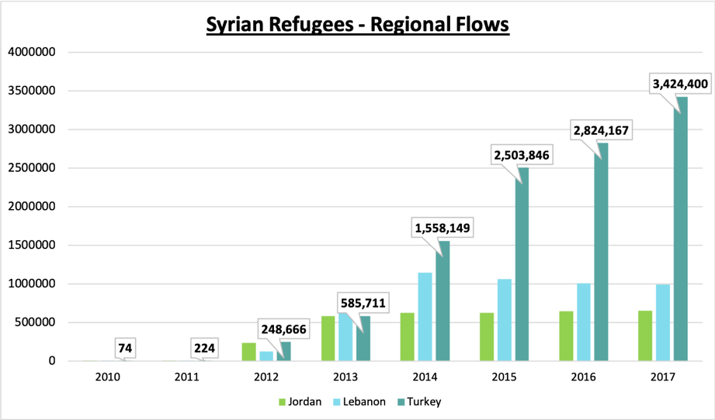

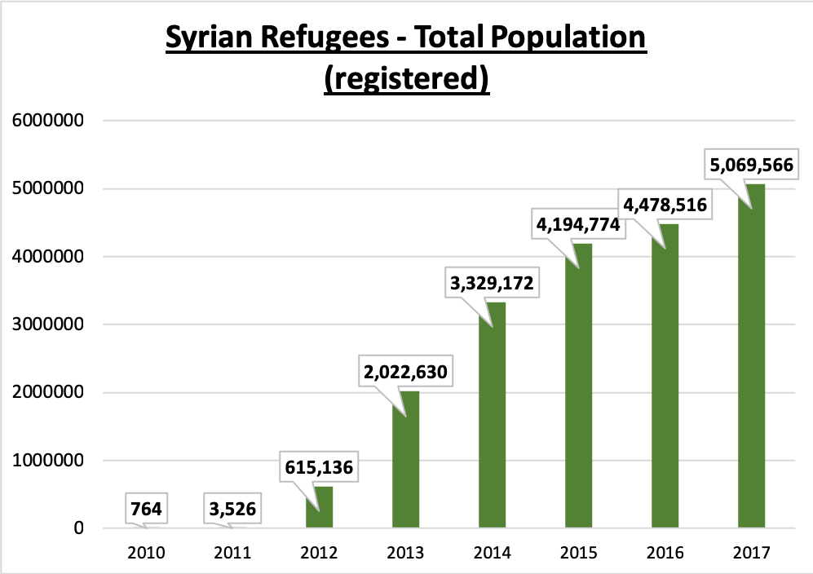

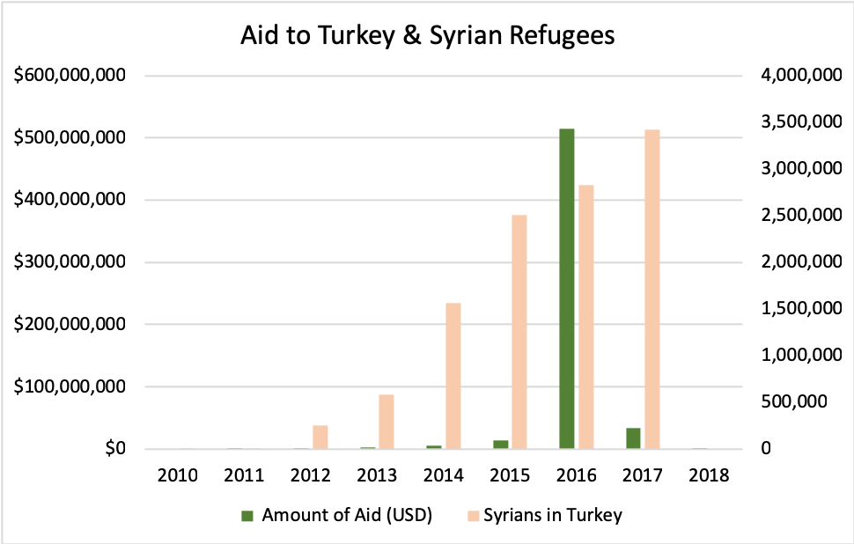

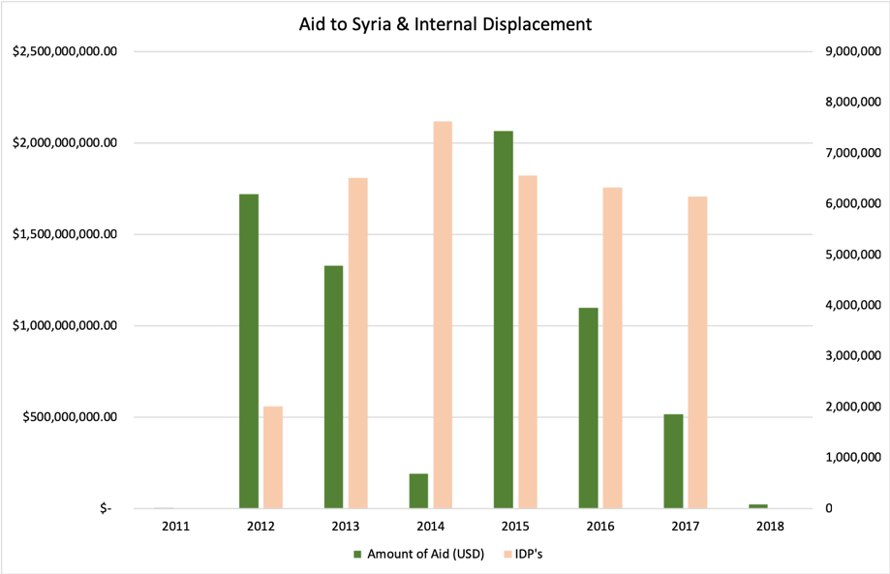

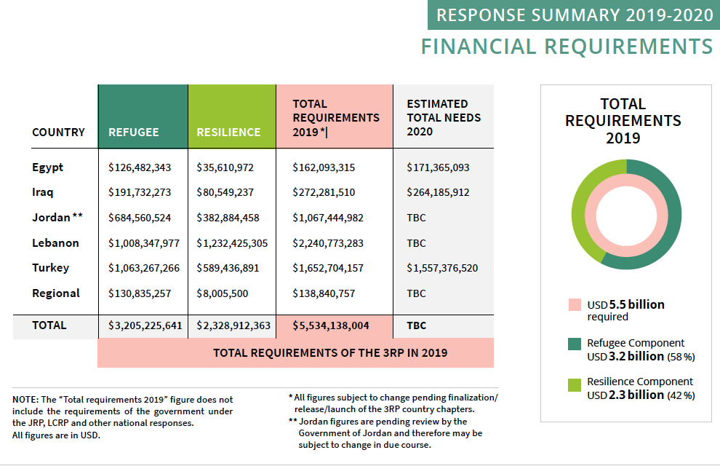

*Source: UNHCR 3RP 2019-2020 Strategic Overview.[29]*

|  |  |  |  |  |
| --- | --- | --- | --- | --- |
| Table 3 |  |  |  |  |
|  |  |  |  |  |
| *Aid to Syria and Total Registered Syrian Refugee Population* | | | |  |
| Year | Amount of Aid (USD) | % Change | Total Population | % Change |
| 2011 | $ 25,644.00 |  | 3526 |  |
| 2012 | $ 1,722,596,279.04 | 6717246% | 615,136 | 17346% |
| 2013 | $ 1,330,098,715.62 | -23% | 2,022,630 | 229% |
| 2014 | $ 191,402,588.64 | -86% | 3,329,172 | 65% |
| 2015 | $ 2,065,318,463.99 | 979% | 4,194,774 | 26% |
| 2016 | $ 1,099,183,172.06 | -47% | 4,478,516 | 7% |
| 2017 | $ 516,954,083.42 | -53% | 5,069,566 | 13% |

**Appendix B – Data**

**Data Sources**

**Refugee Population Data.**

Data for this research was gathered from two main sources. For all data regarding refugee populations, data was gathered from the United Nations High Commissioner for Refugees Population Statistics Time Series Data Portal (UNHCR 2019). The UNHCR data was selected because the UNHCR is the main, if not only, reliable source taking count of refugees; and all individuals who register as refugees register with the UNHCR. This data is the most accurate count of refugees coming from the Syrian Civil War. This data source was used to acquire data on the total number of registered Syrian refugees in Turkey, Jordan, and Lebanon; the total number of Syrian refugees in Turkey; and the total number of internally displaced persons in Syria. All of this data is available in a time series format.

The data portal looks like this:

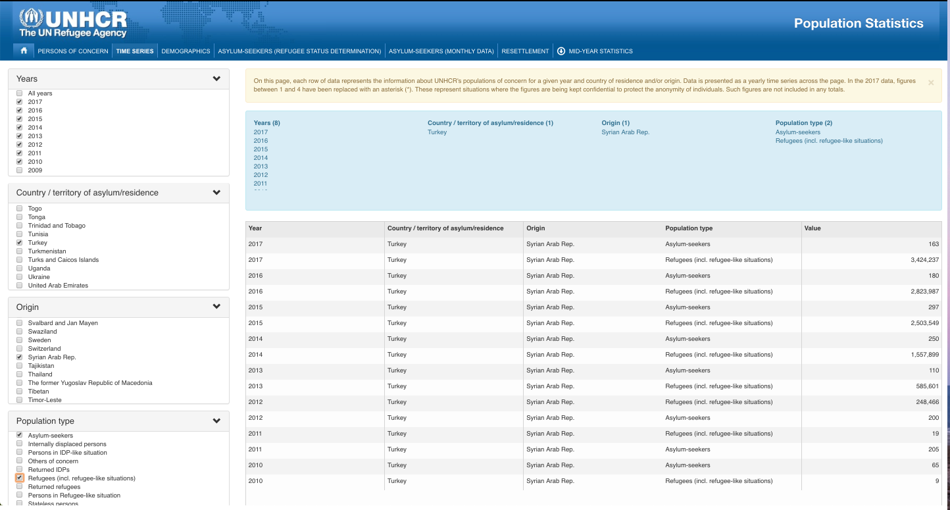

To retrieve the data, the queries were filled out for the desired data. Data was downloaded per individual country: Turkey, Lebanon, Jordan, and Syria. For years, only data ranging from 2010 through 2017 was used to capture the Syrian Civil War years; 2010 is included to show the spike in refugees once the war started. For identifying the population, when downloading data for Turkey, Lebanon, and Jordan, the population types selected were “refugees” and “asylum-seekers”; for Syria data, the population type selected was “internally displaced persons.” In each data download, the country of origin was always the Syrian Arab Republic.

***Data Structure.***

The data downloads from the website as a .csv file. For compatibility with my computer, the file was saved locally as a .xlsx file and uploaded into python as such. The data includes integers and objects which were categorical data. Data downloaded from the Population Statistics portal comes organized by year, with a separate entry for each population type, and the count of that population type in the given year and looks like this :



**US Foreign Aid Data.**

Data detailing the amount of aid provided by the United States was downloaded from ForeignAssistance.gov. This is the central data repository for every organization in the United States who reports and contributes to foreign aid. As such, this data source was selected because it contains a comprehensive data report on all US foreign aid, presented in a standardized manner. There is a standardized structure for reporting, and as a result, the data is all standardized for downloading. Further, all of the data in this repository is disaggregated, so each transaction submitted by an organization has its own data entry. Also, for a given data entry or fund transaction, every organization involved is accounted for so as to trace the path of the transaction from its source to its destination (ForeignAssistance.gov 2019). The entire data sets and codebooks were downloaded for both Syria and Turkey. Each data set contained aid transactions going back far past the beginning of the Syria conflict, so for each data set the start date was modified so that only data since 1/1/2010 would be used. The variables pulled for analysis from the data sample were: “Accountable_Organization", "Implementing_Organization", "Award_Status", "Award_Total_Estimated_Value", "Award_Start_Date", "Award_End_Date", "Award_Transaction_Value", "Award_Transaction_DAC_Purpose_Code", "Award_Transaction_DAC_Purpose_Code_Name", and “Award_Transaction_US_Foreign_Assistance_Category”.

***Data Structure.***

As previously stated, the data provided from ForeignAssistance.gov is disaggregated data. This data includes objects, floats, datetime, and integers. The data also included negative integers for transactions that “de-obligated from a program or activity due to changes in scope of activities.[30] Each data entry includes 38 columns detailing each organization involved in the transaction, start and end dates for the transaction, award status and amount, purposes and purpose codes, treasury code information, and more. The data downloads from the website as a .csv file. For compatibility with my computer, the file was saved locally as a .xlsx file and uploaded into python as such.

**Data Management Plan**

A data management plan helped to better organize and keep track of data throughout the research process. My data management plan included sections for data collection, documentation of data, ethics and legal compliance for data use, storage and backup, data preservation, and data sharing. Some of the data management was made easier because this research relies on secondary data analysis, so the data collection and creation process consisted of searching for and downloading the two data sets as described above. Further, both sets of data are open source, and thus easy to acquire and don’t have limitations for usage. There are no legal or ethical compliance requirements from the data sources, and this also makes for easier data use.

**Data Documentation.**

For documentation of data, I created a data dictionary and updated it regularly as I moved forward in my research process. as I created new variables and tables, I was sure to select a variable name that was easy to read, for example “syria_aid_per_year_table.” While the variable names could be long at times, it helped to keep them organized so that I could quickly and easily differentiate between variables for different things. I also was sure to thoroughly document my codebooks and note what I was doing in each code block and why I was doing certain things throughout the process. Code blocks were kept short so that only small changes were made in each block to avoid errors and to keep the code book clean and easy to read. Below is an example of a code book:

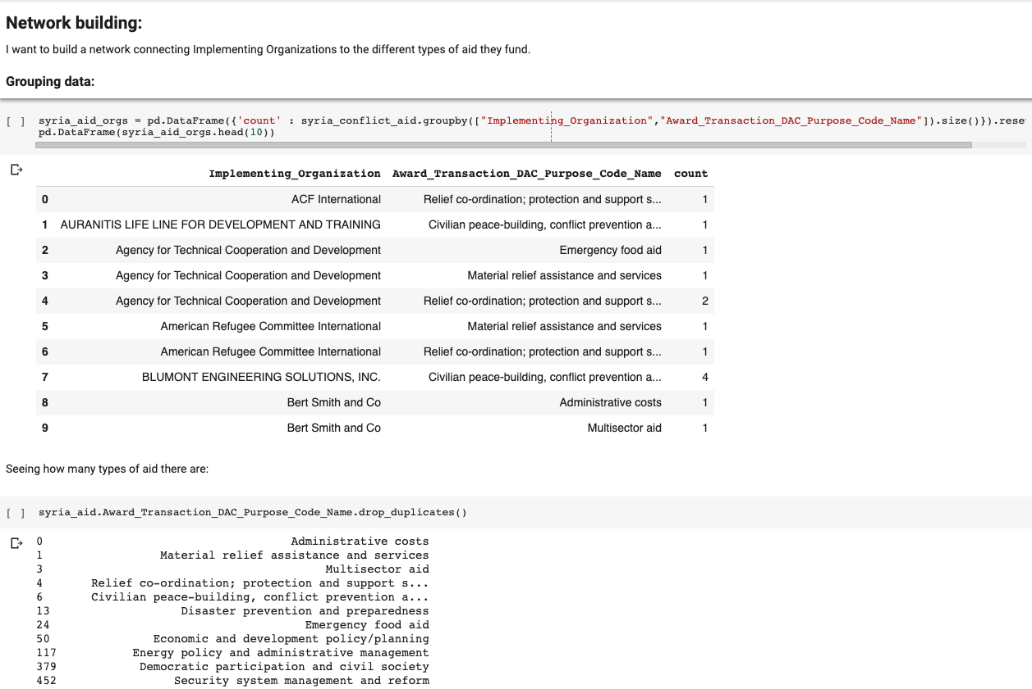

**Data storage.**

For data backup and storage, all data was stored locally and on Github. All code books used for this project are also on a Google Drive folder. To ensure that my local folder and Github repository have all of the same information, I operated Github through my terminal. A README file is included for further explanation of my project. My local folder looks like this:

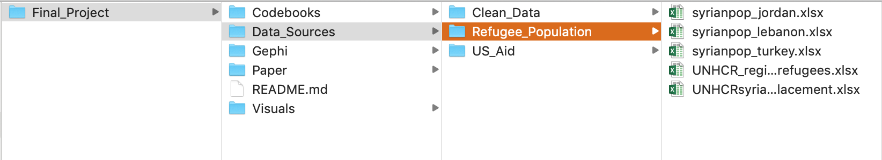

Github looks like this:

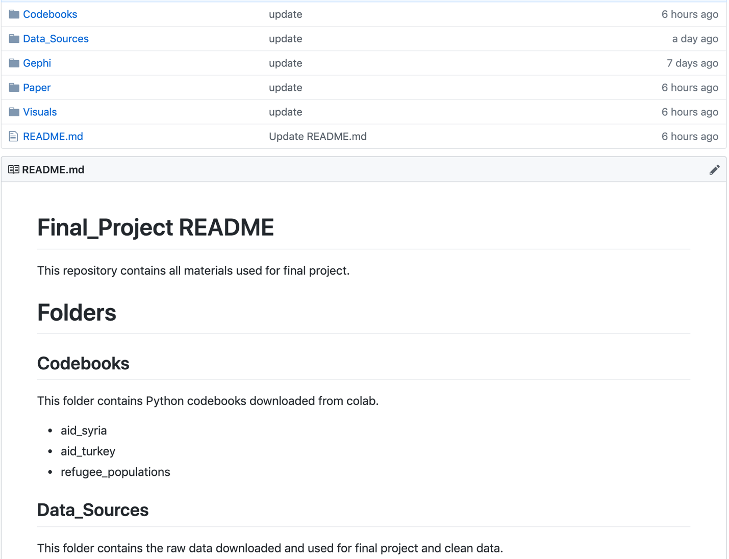

**Data preservation and sharing.**

I plan on preserving this data for as long as possible, because I will likely use it in further research. I will be able to store my data locally and preserve it through Github. My Github repository is public, and I wish for my data to be shared so that others interested in this subject will have access to it. As stated above, the open source nature of my data and ease of access to the original data sources will make for sharing my data, and thus, reproducibility of this research, much easier.

**Workflow**

Below is an image of my project workflow:

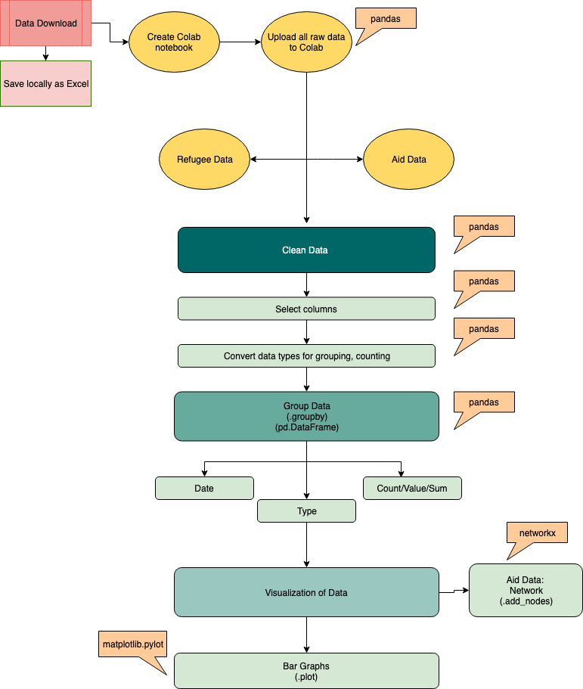

**Validation**

The data selected for this research was selected because both the UNHCR and ForeignAssistance.gov are the most reliable and comprehensive sources for each data type – refugee populations and U.S. foreign aid. The UNHCR is the designated international entity whose sole purpose it is to uphold the 1951 Refugee Convention and its 1967 Protocol; and is mandated to “assume the function of providing international protection … and of seeking permanent solutions for the problem of refugees.”[31] The UNHCR is also mandated to “monitor and protect stateless persons worldwide”[32] and thus the records they keep of the number of registered refugees with the agency and the number of asylees or internally displaced persons is reliable. As a result, validation of this data is both difficult and simple. The UNHCR is *the* source for data on refugee populations and their data is used by most other agencies for knowing how many registered refugees there are. As a result, there aren’t other notable organizations taking count of registered refugees around the world, so there isn’t much to compare this data to. There could be documentation in Turkey, Lebanon, or Jordan for the amount of people crossing the border from Syria, but that information seemed difficult to obtain, and I wanted to use a reliable source like the UNHCR for reporting the refugee population.

The situation is similar for ForeignAssistance.gov. As the central repository for all reporting on US foreign aid from every agency in the United States involved in the humanitarian aid sector, the information is comprehensive and valid. The main goal of the repository is meant to serve as the

main tool for improving transparency in U.S. foreign assistance spending. Transparency and open data enable stakeholders and the general public to better understand U.S. foreign assistance investments around the world, make foreign assistance more useful for development, and help hold ourselves more accountable.[33]

This website is more efficient to use to gather all data on aid to Syria and Turkey rather than going to each individual agency and retrieving their data, which may not be publicly available. The data from ForeignAssistance.gov, similar to that of the UNHCR, is difficult to validate due to the fact that there aren’t other sources reporting all of this information in one place to compare the data to.

One main source used for validating data on UNHCR funding appeals and received aid, and US foreign aid to UNHCR programs is the Financial Tracking Service (FTS). The Financial Tracking Service has been collecting “reports on humanitarian funding flows submitted by Government donors, UN-administered funds, UN agencies, NGOs and other humanitarian actors and partners, including the private sector,” and compiles reports using a specific methodology with aims of increasing visibility of funding, provide an “updated picture of funding flows between donors and recipient organizations,” and also provide “timely monitoring of funding progress” of appeals and response plans.[34] Through FTS, searches can be done on specific funding appeals, such as 3RP, and results will show the amounts provided by each donor over for a given year. A search can also be done on an entire country – Syria – which will turn up all global funding towards the crisis. Donor profiles are also available, so the United States has its own page, and data reporting all US funding over time to specific countries and response plans is available. FTS provides all of their data for download so it can be ran against the aid from ForeingAssistance.gov, and UNHCR appeal overview publications.

Another validation method employed was observing the types of aid requested by the UNHCR for 3RP, and the types of aid provided by the U.S. to Turkey and Syria. This was more so to provide rational as to why these two sources were chosen to use together; other than the fact that the United States is typically the largest provider of aid to 3RP, and all UNHCR programs in general. The UNHCR asks for aid in the categories of protection, food security, basic needs, shelter, education, health, wash, and livelihoods and social cohesion. These categories remain constant over the years. The figure below summarizes this:



*Source: UNHCR 3RP Strategic Overview 2910-2020.[35]*

The United States provides aid to Syria in the categories of: Administrative costs, Material relief assistance and services, Multisector aid, Relief co-ordination; protection and support, Civilian peace-building & conflict prevention, Disaster prevention and preparedness, Emergency food aid, Economic and development policy/planning, Energy policy and administrative management, Democratic participation and civil society, Security system management and reform, Sectors not specified, Decentralization and support to subnational governments, Food aid/Food security programmes, and Elections. The categories provided change over the years, so this is a list of every type of aid provided throughout the term of the civil war. While these are not the same exact types of aid requested by the UNHCR, there are similarities that can be drawn between the categories.

The United States also provides a wide array of aid to Turkey, some of which is meant to target 3RP, and some of which is meant for the development of Turkey in other sectors. It is difficult to discern through the data provided the separation of the aid types to their purposes. The following is a list of all of the types of aid provided to Turkey throughout the term of the Syrian civil war: Civilian peace-building & conflict prevention, Security system management and reform, Sectors not specified, Formal sector financial intermediaries, Basic health infrastructure, Bio-diversity, Narcotics control, Economic and development policy/planning, Relief co-ordination; protection and support, Food aid/Food security programmes, Reproductive health care, Higher education, Multisector aid, Emergency food aid, Business support services and institutions, Agricultural research, Material relief assistance and services, Administrative costs, Democratic participation and civil society, Energy generation, non-renewable sources ñ uns..., Vocational training, Energy education/training, Agricultural education/training, Basic health care, Transport policy and administrative management, Energy generation, renewable sources, Multisector education/training, Financial policy and administrative management, Tuberculosis control, STD control including HIV/AIDS, Family planning, Social/ welfare services, Small and medium-sized enterprises (SME) development, and Telecommunications.

1. United Nations High Commissioner for Refugees. (2019). Syria Regional Refugee Response. Retrieved from <https://data2.unhcr.org/en/situations/syria>
2. United Nations High Commissioner for Refugees. (2019). UNHCR – Syria Factsheet. Retrieved from <https://reliefweb.int/report/syrian-arab-republic/unhcr-syria-factsheet-january-2019>
3. United Nations High Commissioner for Refugees. (2019). 3RP Regional Strategic Overview 2019-2020. Retrieved from <http://www.3rpsyriacrisis.org/cms/sites/default/files/2019-03/RSO.pdf>
4. Ibid.
5. United Nations High Commissioner for Refugees. (2019). Global Response, Donor Profiles. Retrieved from http://reporting.unhcr.org/donor-profiles?y=2012
6. Financial Tracking Service. (2017). Syria regional refugee and resilience plan (3RP) 2017. Retrieved from <https://fts.unocha.org/appeals/552/summary>
7. United Nations High Commissioner for Refugees. (2019). 3RP Regional Strategic Overview 2019-2020.
8. ForeignAssistance.gov. (2019). Syria Foreign Assistance. Retrieved from <https://www.foreignassistance.gov/explore/country/Syria#download>
9. Ibid.
10. ForeignAssistance.gov. (2019). Turkey Foreign Assistance. Retrieved from <https://www.foreignassistance.gov/explore/country/Turkey>
11. United Nations High Commisisoner for Refugees. (2019). Syria Regional Refugee Response. Retrieved from <https://data2.unhcr.org/en/situations/syria>
12. Betts, A. (2010). The Refugee Regime Complex. *Refugee Survey Quarterly,* *29*(1), 12-37.
13. United Nations High Commissioner for Refugees. (2019). Refugees and Asylum Seekers in Turkey. Retrieved from <https://www.unhcr.org/tr/en/refugees-and-asylum-seekers-in-turkey>
14. National Legislative Bodies / National Authorities, *Turkey.*(2014).Temporary Protection Regulation, 22 October 2014. Retrieved from https://www.refworld.org/docid/56572fd74.html 
15. Kreibaum, M. (2016). Their Suffering, Our Burden? How Congolese Refugees Affect the Ugandan Population. *World Development*, 78, 262-287.
16. Power, S. (2016). Siege Warfare in Syria: Prosecuting the Starvation of Civilians. *Amsterdam Law Forum, 8*(2), 1 – 22. <http://amsterdamlawforum.org/article/view/368>
17. Ibid.
18. Nunn, N., & Qian, N. (2014). US food aid and civil conflict. The American Economic Review, 104(6), 1630-1666. doi:10.1257/aer.104.6.1630
19. Zürcher, C. (2017). What do we (not) know about development aid and violence? A systematic review. World Development, 98, 506-522. doi:10.1016/j.worlddev.2017.05.013
20. Types of aid for Turkey: Civilian peace-building, conflict prevention …, Security system management and reform, Sectors not specified, Formal sector financial intermediaries, Basic health infrastructure, Bio-diversity, Narcotics control, Economic and development policy/planning, Relief co-ordination; protection and support …, Food aid/Food security programmes, Reproductive health care, Higher education, Multisector aid, Emergency food aid, Business support services and institutions, Agricultural research, Material relief assistance and services, Administrative costs, Democratic participation and civil society, Energy generation, non-renewable sources ñ uns..., Vocational training, Energy education/training, Agricultural education/training, Basic health care, Transport policy and administrative management, Energy generation, renewable sources..., Multisector education/training, Financial policy and administrative management, Tuberculosis control, STD control including HIV/AIDS, Family planning, Social/ welfare services, Small and medium-sized enterprises (SME) development..., Telecommunications
21. Types of aid to Syria: Administrative costs, Material relief assistance and services, Multisector aid, Relief co-ordination, protection and support s..., Civilian peace-building, conflict prevention …, Disaster prevention and preparedness, Emergency food aid, Economic and development policy/planning, Energy policy and administrative management, Democratic participation and civil society, Security system management and reform, Sectors not specified, Decentralization and support to subnational go..., Food aid/Food security programmes, Elections
22. Graph of data provided in Appendix A.
23. Graph of data provided in Appendix A.
24. Graphs of data provided in Appendix A.
25. Explanation of data provided in Appendix B.
26. Department of State. (2019). U.S. Humanitarian Assistance in Response to the Syria Crisis. Retrieved from <https://www.state.gov/r/pa/prs/ps/2019/03/290350.htm>
27. A graph is available in Appendix A.
28. Zürcher, C. (2017). What do we (not) know about development aid and violence? A systematic review. World Development, 98, 506-522. doi:10.1016/j.worlddev.2017.05.013
29. United Nations High Commissioner for Refugees. (2019). 3RP Regional Strategic Overview 2019-2020. Retrieved from <http://www.3rpsyriacrisis.org/cms/sites/default/files/2019-03/RSO.pdf>
30. ForeignAssistance.gov. (2019). Frequently Asked Questions, Data Questions, Why do negative numbers appear at the operating unit and sector levels?. Retrieved from <https://www.foreignassistance.gov/learn/faqs>
31. Division of Internal Protection. (2013). Note on the Mandate of the High Commissioner for Refugees and His Office. Retrieved from <https://www.unhcr.org/en-us/protection/basic/526a22cb6/mandate-high-commissioner-refugees-office.html>
32. United Nations High Commissioner for Refugees. (2014). Protecting Refugees & The Role of UNHCR. Retrieved from <https://www.unhcr.org/509a836e9.pdf>
33. ForeignAssistance.gov. (2019). About ForeignAssistance.gov. Retrieved from <https://www.foreignassistance.gov/learn/about-fa>
34. Financial Tracking Service. (n/d). About FTS. Accessed on May 8, 2019. Retrieved from <https://fts.unocha.org/content/about-fts-1>

   
35. United Nations High Commissioner for Refugees. (2019). 3RP Regional Strategic Overview 2019-2020.